Lecture 4 : Micro Level
Online Market Analysis – Micro Level

1- Introduction :
Understanding the digital marketing environment is crucial for the success of marketing strategies. A marketer who understands its components can better control campaign outcomes by targeting customers based on key influencing factors. This knowledge also helps in creating effective strategies and improving existing ones.
Digital Environment Analysis :
Understanding the digital marketing environment components is essential to achieving success when it comes to digital marketing strategies.
A marketer who deeply understands the components of the digital marketing environment can better control campaign results by tailoring strategies to customer behavior. This knowledge enables the creation of more relevant, effective, and optimized marketing approaches.
Definition: The digital market environment, , consists of micro and macro variables.
The micro-environment in digital marketing refers to the immediate, close-range factors that directly impact a company's ability to serve its customers and shape its digital operations. Key components include the company itself, its suppliers, marketing intermediaries, customers, competitors, and the public. Understanding these elements is crucial for creating and adapting effective digital strategies to meet evolving market needs.
2. Definition of Micro-Level Market Analysis :
The first component of the digital marketing environment is the micro-environment. The micro-environment is referred to as the “operating environment” and focuses on customers’ needs and wants Micro-level online market analysis refers to the detailed examination of individual market components within the online environment, including Objectives of Micro-Level Market Analysis Identify consumer needs and preferences.
Understand buying behavior and online decision-making patterns.
Evaluate competitor strategies and online presence.
Optimize product positioning and pricing.
Measure customer satisfaction and loyalty in real-time.
Improve digital marketing performance based on evidence.
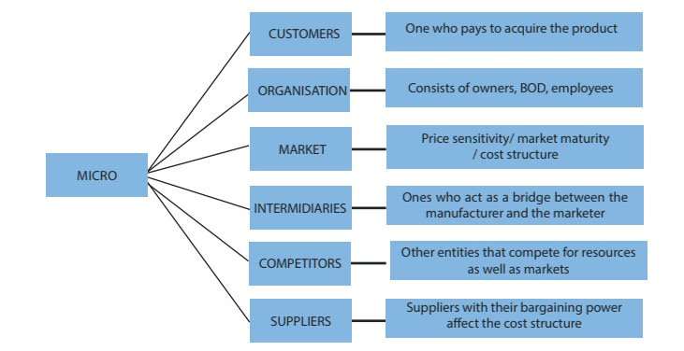

Consumer and Digital Marketing :
Consumers and digital marketing significantly influence each other. By understanding consumer behavior and digital marketing, companies can design their marketing efforts to engage their target audience effectively. Let’s explore how consumer behavior affects digital marketing strategies and why analyzing it is essential in this context.
How Consumer Behavior Affects Digital Marketing Strategies :
Consumer behavior provides valuable insights into how individuals discover, evaluate, and purchase products or services. By analyzing consumer behavior, companies can identify touchpoints in the customer journey and optimize their digital marketing strategies accordingly.
For example, if a company realizes that many consumers discover its products through social media, it can invest more resources in creating engaging content and campaigns on those platforms.
The Importance of Analyzing Consumer Behavior in Digital Marketing :à
Analyzing consumer behavior involves collecting and interpreting data related to consumer preferences, motivations, and purchasing patterns. This analysis uses various methods such as surveys, focus groups, and web analytics tools.
By conducting a comprehensive analysis of consumer behavior, companies can better understand their audience and make data-driven decisions to improve their digital marketing strategies.
Furthermore, analyzing consumer behavior allows companies to identify trends and patterns that can guide future marketing initiatives.
By regularly monitoring consumer behavior and digital marketing, companies can adapt to stay ahead of changing trends in the digital landscape and ensure they remain relevant and appealing to their target audience.
Competitors
Digital Competition Analysis :
Digital competition analysis is a fundamental strategy for business growth, and knowing how to conduct a competitor analysis in digital marketing is crucial for digital marketers.
How to Conduct Competitor Analysis in Digital Marketing :
To perform a digital marketing competitive analysis, start by identifying your competitors. Analyze their websites, content strategies, SEO performance, social media presence, advertising tactics, and customer feedback. Assess their online presence to understand their strengths and weaknesses.
Use the insights gained to enhance your own digital marketing strategy, strengthen your advantages, and address weaknesses—ensuring you remain competitive in the online marketplace.

The main steps can be summarized as follows:
- Identify your competitors: Start by searching on Google for the product or service category you offer. List both direct competitors (those offering similar products/services) and indirect competitors (those solving the same problem differently).
- Analyze their website and user experience: Visit each competitor’s website. Observe the overall design, user experience, calls-to-action, blog quality, mobile responsiveness, and unique features or tools. Tools like SimilarWeb can provide insights into website traffic and sources.
- Examine their content strategy: Determine what type of content they produce and how often — whether it’s videos, blog posts, infographics, or podcasts. This helps you understand what type of content resonates most with your shared audience.
- Review SEO and keywords: Tools such as SEMrush or Ahrefs can reveal which keywords your competitors rank highly for. This helps you refine your SEO strategy and identify keyword opportunities.
- Evaluate social media presence: Check which platforms they are active on, posting frequency, content type, and audience engagement. Social listening tools like Brandwatch or Mention can be helpful.
- Review advertising tactics: Use tools like SpyFu or AdEspresso to get insights into your competitors’ online advertising strategies. Take note of their ad copy, visuals, and the platforms they prioritize.
- Assess email marketing: If possible, subscribe to your competitors’ email lists. This gives you an idea of their email marketing frequency, tone, and promotional offers.
- Analyze feedback and reviews: Websites such as Yelp, Google Reviews, or industry-specific review platforms provide valuable insights into what customers like or dislike about your competitors.
- Identify strengths and weaknesses: After gathering all this information, list what each competitor does well and where they fall short.
- Draw actionable insights: Finally, turn your findings into action. Based on what you’ve learned, adjust your digital marketing strategy — whether it’s improving content, optimizing your website, or investing more in specific advertising channels.
Suppliers:
In the digital marketplace, suppliers are entities that provide businesses with the resources, tools, and services necessary to run digital marketing campaigns. These may include technology and software providers, content creators, advertising platforms, and data analytics services.
Definition of the Digital Supply Chain
Let’s begin by defining the supply chain, then narrow it down to the digital context. A supply chain is a system of organizations, people, activities, information, and resources involved in moving a product or service from a supplier or manufacturer to the customer. It can be highly complex, with multiple layers of companies working in sync toward shared goals to meet end-customer needs.
One of the most precise definitions in our context is:
“A digital supply chain is an intelligent, efficient, value-driven process that generates new forms of revenue and business value for organizations by leveraging new technological and analytical methods. It is not about whether goods and services are digital or physical, but rather about how supply chain operations are managed using a wide range of innovative technologies such as unmanned aerial vehicles, cloud computing, the Internet of Things (IoT), and others.”
The main goal of the digital supply chain is to make collaboration between different parties and companies smoother, faster, more transparent, and more secure. For example, by using an online collaboration tool, purchasing efficiency can be improved by up to 100%. This clearly illustrates how digitization enhances the overall effectiveness of supply chain collaboration.

