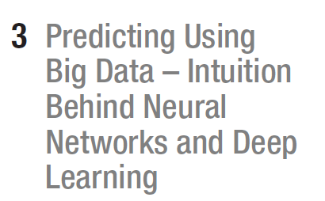


People are fond of saying that the brain is like a computer. But is it?

The passage highlights a long-standing paradox in artificial intelligence: computers excel at tasks that are computationally demanding for humans—such as arithmetic or large-scale memory operations—yet struggle with abilities that come naturally even to very young children, like recognizing everyday objects. Although machines can perform complex calculations flawlessly and at extraordinary speed, teaching them to distinguish simple visual categories (e.g., dogs versus cats) took decades of research. This contrast illustrates the core challenge of AI: cognitively “easy” human abilities often require deep, sophisticated models for machines to replicate.
many tasks humans find effortless—such as reading messy handwriting, translating language, navigating physical environments, or maintaining natural conversation—were beyond the capabilities of computers until recently. Although machines struggled for decades with these intuitive abilities, progress in AI has enabled systems to perform them more effectively, even approaching conversational realism associated with the Turing Test. This shift became possible when researchers began designing algorithms inspired by the human brain, specifically artificial neural networks, which allow computers to process information in ways closer to human perception and cognition.
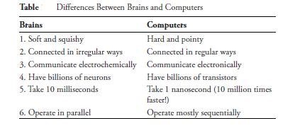
the brain’s massively parallel structure with the computer’s sequential “von Neumann bottleneck.” While humans perform simple arithmetic through a slow, step-by-step procedure resembling a weak computer, the brain itself operates through millions of neurons that update simultaneously. This parallelism gives humans powerful perceptual and adaptive capabilities, even though they rely on tools like pencil and paper for precise calculations. The text also introduces an example of a natural biological response—pupil contraction in bright light—to illustrate how the brain efficiently handles complex sensory regulation in ways fundamentally different from conventional computing.

