**Lesson 1: Marketing Strategy and Marketing Plan** 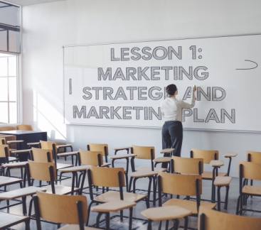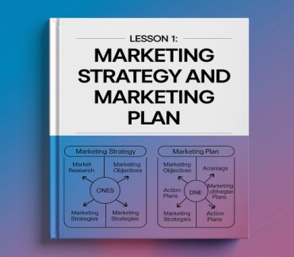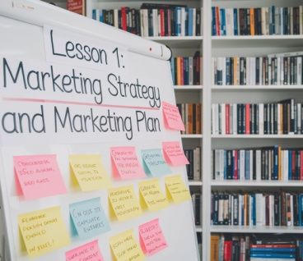

**Preparing a Marketing Plan**

When preparing a marketing plan, a marketing manager considers the following **key questions**:

1. **Business Definition**
   * How can I best define my business? What kind of company are we?
2. **Objectives Check**
   * Are my objectives SMART?
3. **Focus on Retention vs. Acquisition**
   * Should I focus on repeat business to retain current customers, or should I focus on gaining new customers?
4. **Customer Analysis**
   * Do my customers share any patterns, habits, or repetitive behaviors, such as shopping in the same types of stores?
5. **Market Segmentation**
   * Are there any market segments or groups of consumers that are underserved or not sufficiently provided for?
6. **Product Viability**
   * Is the product or service viable? Will it make a profit?
7. **Product Accessibility**
   * Is it easy for the audience to obtain or start using?
8. **Evaluation of Past Marketing Methods**
   * How effective were previous marketing methods?
9. **Medium Selection**
   * Which marketing mediums or communication channels are most suitable for my audience?
10. **Single vs. Cross-Section Media Approach**

* Should I use multiple media channels or focus on one primary medium?

1. **Clarity of Marketing Message**

* Is my marketing message clear and easy for the audience to understand?

1. **Consistency in Marketing Efforts**

* How can I ensure a consistent look and feel across all marketing efforts?

1. **Timing of Campaigns**

* Can I time my marketing campaigns to coincide with seasonal sales or product launches?

1. **Cost Analysis**

* Is the cost reasonable compared to sales? Are we making enough to cover our expenses?

1. **Cost per Customer**

* What is the cost per customer acquired?

1. **Measurable Objectives**

* Are there clear objectives that allow for measuring results?

1. **Audience Feedback**

* How can I gather feedback from my audience? What kind of market research should I conduct?

**Marketing Strategy vs. Marketing Plan**

* **Marketing Strategy**
  + The marketing strategy outlines how the company will position itself, its products, or services within a competitive marketplace. It includes a detailed look at target markets, product and pricing policies, and proposed marketing and promotional initiatives.
* **Marketing Plan**
  + The marketing plan is a written document specifying the chosen marketing methods (e.g., advertising, promotions) and specific marketing actions (e.g., seasonal promotions) to reach objectives. It details the resources required, both financial and human, to achieve the desired outcomes, such as increased sales or a successful product launch within a set timeframe.

**Developing the Marketing Plan: AOSTC Stages**

Using the **AOSTC** stages, a structured approach to developing a marketing plan involves the following:

|  |  |  |  |  |  |  |  |  |  |  |  |  |  |  |  |  |  |  |  |
| --- | --- | --- | --- | --- | --- | --- | --- | --- | --- | --- | --- | --- | --- | --- | --- | --- | --- | --- | --- |
| |  |  |  | | --- | --- | --- | | Stage | Description | Key Questions and Considerations | | Analysis | Assess the company, market, product/service, and competitors. | - What are our strengths and weaknesses? - What market trends affect us? - Who are our competitors? | | Objectives | Define clear, measurable marketing goals. | - Are our objectives SMART? - What is the desired outcome (e.g., sales, customer acquisition)? | | Strategies | Outline the approach to achieve the objectives and target specific market segments. | - Which market segments are we focusing on? - How will we position ourselves? - What is our pricing approach? | | Tactics | Specify actionable steps to execute the strategy (e.g., promotional offers, advertising campaigns). | - What marketing channels will we use? - How will we maintain a consistent brand message? - What resources are needed? | | Control | Establish metrics and evaluate the success of the plan to make adjustments as needed. | - How will we track progress? - What feedback mechanisms are in place? - What adjustments are required based on results? | |  |

**Key Definitions**

1. **Market Segments**
   * Groups of consumers with similar needs or purchasing desires.
2. **Target Audience**
   * The consumers, clients, or customers you aim to attract.
3. **Company Definition**
   * A description of the company, the product/service, and its competitors.
4. **Tactics**
   * Detailed steps to fulfill the marketing strategy.
5. **Communication Techniques**
   * Methods for reaching and engaging consumers.
6. **Marketing Mix**
   * The combination of different elements used to market a product or service

**AOSTC Exercise**

**For the new eco-friendly water bottle, answer the following:**

1. **Analysis:** Who is the target audience?
2. **Objectives:** What is one goal for the first 6 months?
3. **Strategy:** How will you promote the product?
4. **Tactics:** Name one marketing method.
5. **Control:** How will you measure success?

**Instructions:** Write one sentence for each question

