***Brand management***

When you think of brands, which ones come to mind? Coca-Cola, Starbucks, McDonald’s, Walmart, Apple, Nike. Millions of brands populate our world, but the true test of their longevity and resilience is brand management. Without brand management, none of these brands could have achieved the lasting success they have.

**What is brand management?**

brand management is an “umbrella term that describes all the facets of design, placement, marketing, advertising, and distribution that foster identifying and developing a brand personality.” Brand management encompasses more than just the aesthetics of a brand. It involves the management of an organization’s brand identity, or “all elements that a company creates to portray the right image to its consumer.” This includes packaging, press releases and public relations, customer service, event management, retail experience, how executive leadership styles are expressed in the news, or any “touch points” with customers throughout a brand experience.

Brand management is the vague strategy of guiding public perception of a good, product, service, or company. Brand management is heavily tied to creating brand equity, loyalty, and recognition. It is also formulated by a dedicated team, most often after the marketing team has built-out an initial marketing plan. By effectively building out a brand management strategy, a company may experience stronger short-term and long-term financial success.

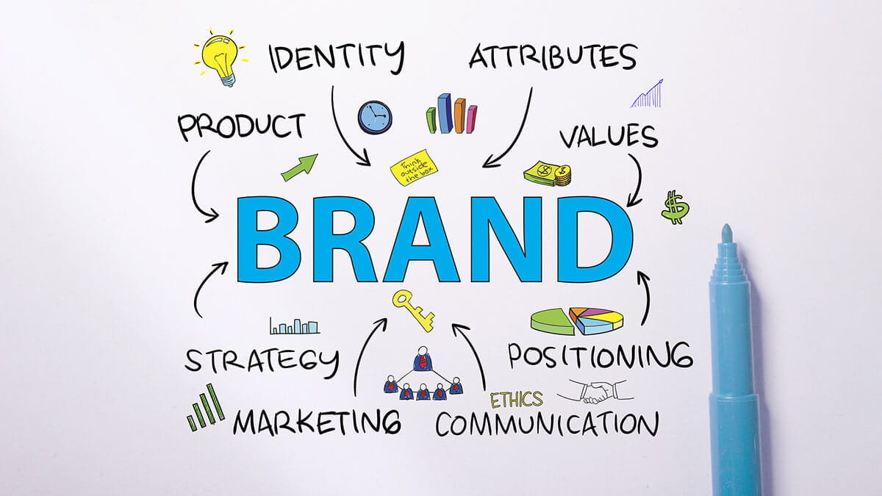

Brand management dictates how public markets perceive goods. Without brand management, consumers may not become loyal to a product line or may not choose to repeat purchases with a company after a positive experience. Effective brand management may lead to not only to greater sales quantities in the short-term but greater long-term financial success due to long-term customers.

The goal of brand management is to form a specific perception about a product or company. By strategically determining the font, language, style of messaging, and marketing plans, the brand management team hopes to make the public see a product or company in a specific light.

**How Brand Management Works**

[Brands](https://www.investopedia.com/terms/b/brand.asp) have a powerful influence on customer engagement, competition in the markets, and the management of a company. A [strong master brand presence](https://www.investopedia.com/terms/m/masterbrand.asp) in the market differentiates a company’s products from its competitors and creates brand affinity for a company’s products or services.

A brand that has been established has to continually maintain its brand image through brand management. Effective brand management increases [brand awareness](https://www.investopedia.com/terms/b/brandawareness.asp), measures and manages brand equity, drives initiatives that support a consistent brand message, identifies and accommodates new brand products, and effectively positions the brand in the market.

It takes years to establish a brand, but when it finally occurs, it has to still be maintained through innovation and creativity. Notable brands that have established themselves as leaders in their respective industries over the years include [Coca-Cola](https://www.investopedia.com/articles/markets/112515/how-does-cocacola-actually-make-money.asp), McDonald’s, Microsoft, IBM, Procter & Gamble, CNN, Disney, Nike, Ford, Lego, and Starbucks.

**By**[**MITCHELL GRANT**](https://www.investopedia.com/mitchell-grant-4686317)**, Updated May 21, 2023**

https://www.investopedia.com/terms/b/brand-management.asp