**Marketing**

1. **Definition**

1a) Here is a definition of Marketing. Complete it by inserting the following verbs in the gaps:

Design, develop ,identify, influence, modify ,persuade

Marketers have to……………………………………or anticipate a costumer need; ……………………………a product or service that meets that need better than any competing products or sevices; …………………… target customers to try the product or service; and, in the long term, …………………… it to satisfy changes in consumer needs or market conditions. Marketers can …………………………….. particular features, attractive packaging, and effective advertising, that will……………………. Consumers’ wants. Marketing thus begins long before the product development, distribution, advertising, promotion, product improvement, and so on.

Here is a second definition of marketing ( as opposed to selling)

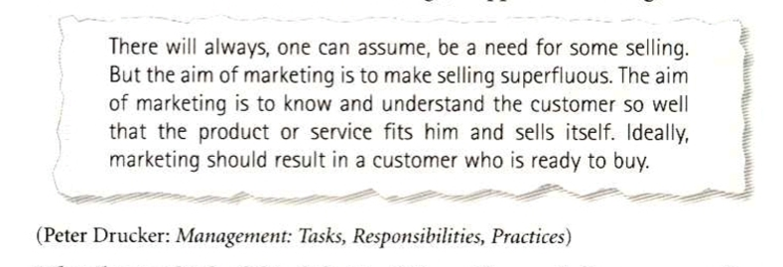

**1b) Vocabulary**

Match up the word with its definition:

|  |  |
| --- | --- |
| 1-Distribution channel  2-To launch a product  3-Market opportunities  4-Market research  5-Market segmentation  6-Packaging  7- Point of sale  8-Product concept  9-Product features  10-Sales representative | A- all the companies or individuals involved in moving particular good or service from the producer to the consumer  B-an idea for a new product , which is tested with target consumers before the actual product is developed  c-attributes or characteristics of a product: quality,price, reliability, etc  D-dividing a market into distinct groups of buyers who have different requirements or buying habits  E- places where goods are sold to the public-shops, stores,kiosks,market stalls…  F-possibilities of filling unsatisfied needs in sectors in which a company can profitably produce goods or service  G- someone who contacts existing and potential customers and tries to persuade them to buy goods or sevices  H- collecting, analyzing and reporting data relevant to a specific marketing situation  I-to introduce a new product onto the market  J- wrappers and containers in which products are sold |

1c- look quickly through the following text and decide which paragraphs are about these subjects:

………………….. – company- to-company marketing

…………………. – identifying market opportunities

………………… - the marketing mix

……………… - the selling and marketing concepts

……………… - the importance of market research

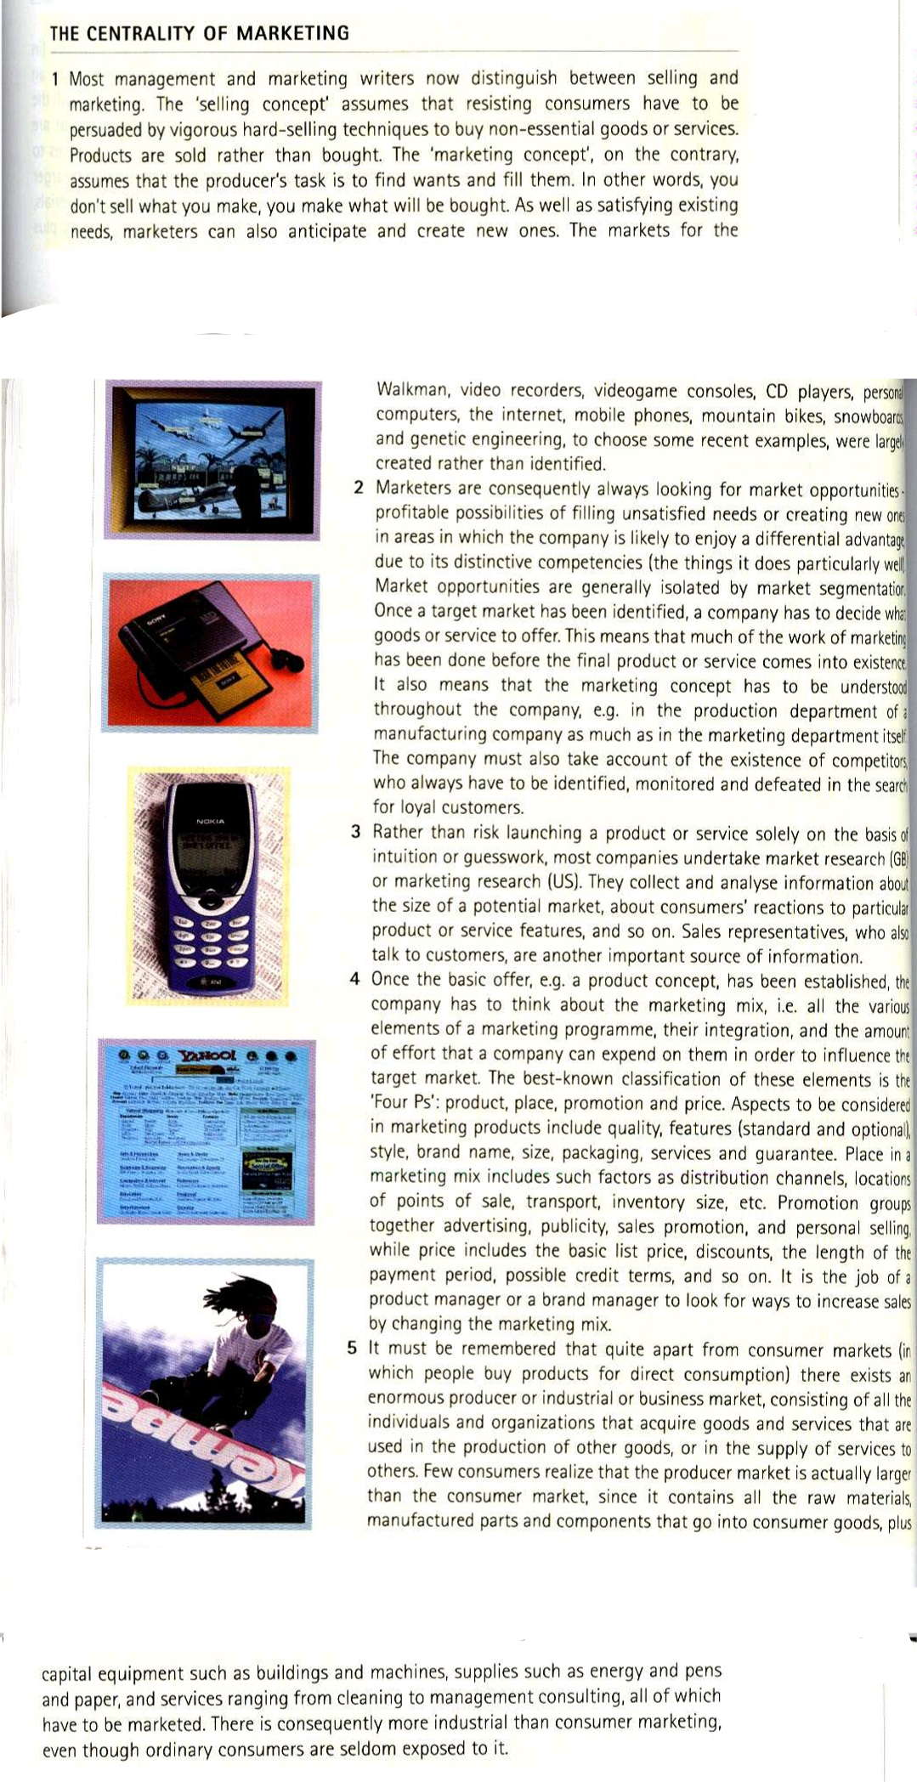

**1d- Comprehension**

Which of the following three paragraphs most accurately summarizes the text in 1c, and why?

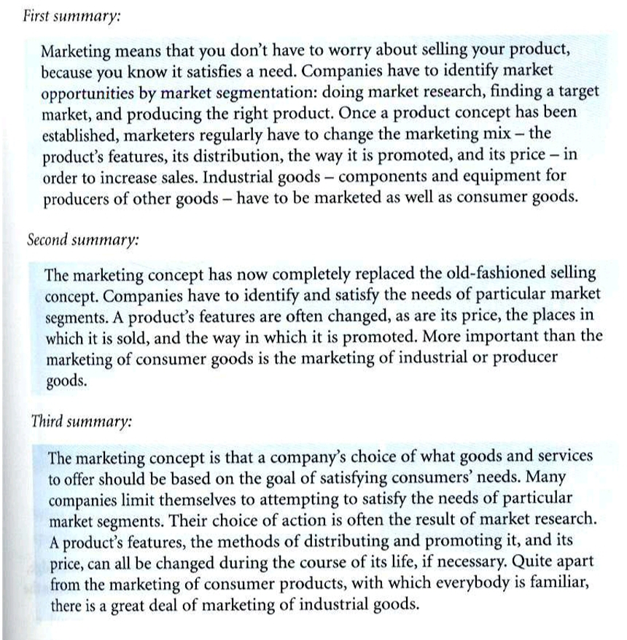

* **Transtale ONE of these summaries.**

1e- look at the following diagrams from Marketing Management by Philip Kotler.

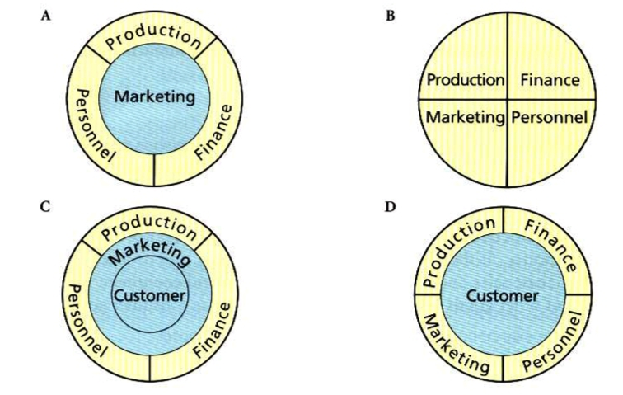

According to the text in 1C, which of these diagrams best illustrates a company that has adopted the marketing concept?