**Lesson 01: Language Practice “International Women's Day”**

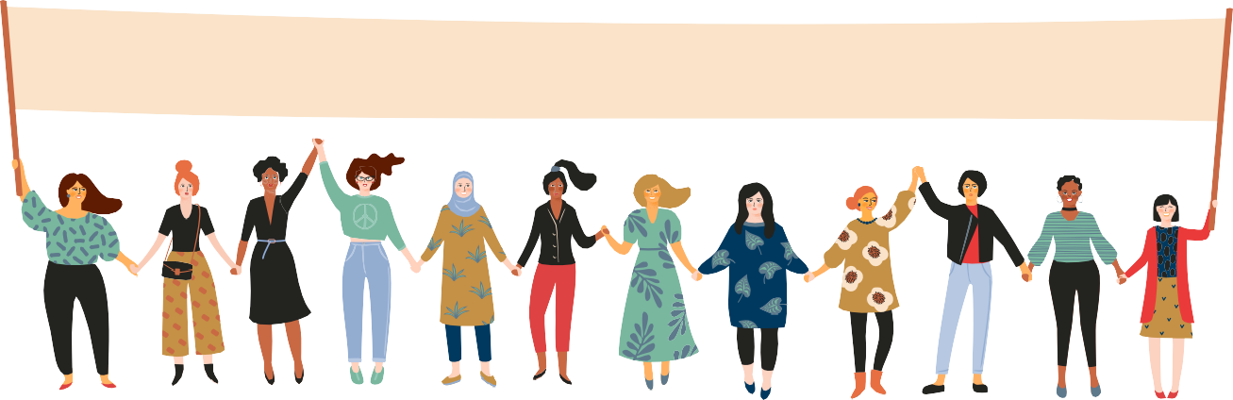

International Women's Day

What is International Women's Day?

International Women's Day (IWD) is a global event that takes place on 8 March. It is a day to celebrate women's achievements in a wide number of areas while calling for gender equality.

IWD was first observed on 8 March, 1908, when 15,000 marched through New York City. They wanted to raise awareness for better working conditions for themselves and for their children. They also wanted to be given the right to vote.

International Women's Day was adopted in 1975 by the United Nations as an official, world-wide celebration of women's rights and world peace. It is now an official holiday in over 30 countries. In some countries, women are given small gifts and flowers, and in other countries the day is treated like Mother's Day.

Some important topics to think about on International Women's Day are:



Did you know?

Women, on average, earn 25-40% less than men who do the same job.

* Girls and women in leadership
* Gender equality
* Personal and family safety
* Poverty
* Access to education
* Empowerment

**LESSON PRACTICE: HOMEWORK**

**Watch the video on the history of International Women's Day and decide whether the following statements are True or False.**

**The video Link:** [**https://www.youtube.com/watch?v=N0ZpG2JXZgQ**](https://www.youtube.com/watch?v=N0ZpG2JXZgQ)

1. International Women's Day takes place every year on 19th March.

a) True

b) False

2. International Women's Day celebrates the achievements of women worldwide.

a) True

b) False

3. The first International Women's Day was celebrated on 8th March, 1911.

a) True

b) False

4. One million women rallied in support of their rights on the first International Women's Day.

a) True

b) False

5. International Women's Day is officially supported by the United Nations.

a) True

b) False

6. The 100 anniversary of International Women's Day took place in 2012.

a) True

b) False

7. Women in business or politics have been paid equally to their male counterparts since 2000s.

a) True

b) False

8. Women's education and health is worse than that of men.

a) True

b) False

9. International Women's Day is an official holiday in many countries.

a) True

b) False

10. In all these countries International Women's Day has the status of Mother's Day.

a) True

b) False