**Lesson 1: Marketing Strategy and Marketing Plan**

**Preparing a marketing plan:**

A marketing manager has made notes while preparing a marketing plan:

*QUESTIONS TO ASK:*

-How can I best define my business? What kind of company are we?

Are my objectives SMART?

-Should I focus on repeat business, thereby keeping the customers we've

got, or should I focus on gaining new customers?

-Do my customers share any patterns, habits or repetitive behaviours? For example, do they all shop in the same kinds of shops?

-Are there any market segments or groups of consumers that are underserved

not provided for enough or at all?

-Is the product or service viable? Will it make a profit?

-Is it accessible? Is it easy for the audience to get or start using?

-How well did previous marketing methods work?

-Which marketing mediums, or communication channels, are best for му

audience?

-Should I use a cross-section of media or should I just focus on one medium?

-Do I have a clear marketing message? One that is easy for the audience to understand?

-How can I ensure the same look and feel across all my adverts and marketing efforts?

-Can I time my marketing campaigns to coincide with seasonal sales or

product launches?

-How much is the cost compared to sales? Are we making enough money to cover our costs?

-How much is the cost per customer?

-Do I have clear objectives so that I can measure the results?

-How can I get feedback from my audience? Which kind of market

research should I carry out?

**Marketing Strategy Vs Marketing Plan**

A company's marketing strategy describes how it will position itself and the products it sells or the services it provides in the competitive marketplace. The strategy includes a discussion of target markets, product and pricing policies, and proposed marketing and promotional initiatives.

The company's marketing plan is the written document which details the marketing methods selected (advertising, price promotions, etc.) and specific marketing actions or marketing activities (for example, a back-to-school promotional offer). It also examines the resources needed (both financial and human) to achieve specified marketing objectives, such as an increase sales or a successful product launch, over a given period of time.

**Developing the marketing plan**

You can develop a marketing plan using the stages known as AOSTC (Analysis, Objectives, Strategies, Tactics and Control).

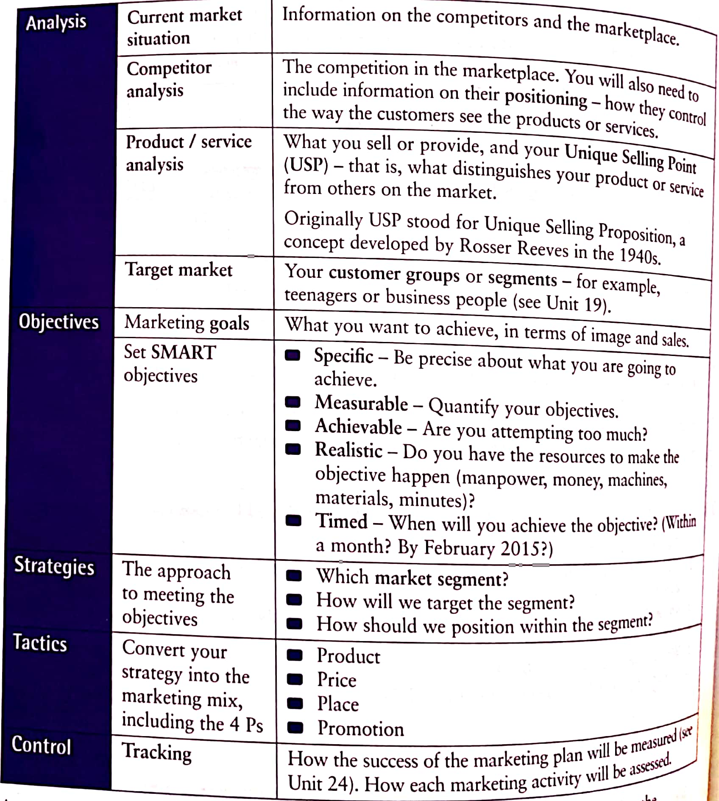

**Definitions to use:**

1. groups of consumers with similar needs or purchasing desires
2. the consumers, clients or customers you want to attract
3. a definition of the company, the product / service and the competition
4. detailed information about how to fulfil the marketing strategy
5. the techniques you can use to communicate with your consumers
6. the combination of different elements used to market a product or service

