**An Introduction to Forensic Accounting**

Contrary to popular belief, 'forensic' has nothing to do with death. 'Forensic' means being able to meet the exacting standards of a court of law (thus forensic science, forensic psychiatry, forensic climatology etc.). Some forensic accountants' primary skills include an understanding of the legal process; how to conduct investigations; conducting financial analyses and other accounting procedures at a level acceptable to the legal system.

Until recently, detecting fraud or white collar crime was thought to be part of the accounting function. Fraud was something the internal or external auditors were supposed to guard against by their periodic audits. However, we now know the auditors can only check for the compliance of a company's books to generally accepted accounting principles and company policy. Thus, a new category of accounting was needed to substantiate the fraud for companies who identified fraudulent transactions. This area of accounting is known as forensic accounting

Forensic accountants utilise accounting, auditing and investigative skills when conducting an investigation. Equally critical is their ability to respond immediately and to communicate financial information clearly and concisely in a courtroom setting. Forensic accountants are trained to look beyond the numbers and deal with the business reality of the situation.

Forensic accountants are multi-disciplinary and have a wide range of experience in the forensic and investigative field. They are frequently called upon to serve as expert witnesses and litigation consultants.

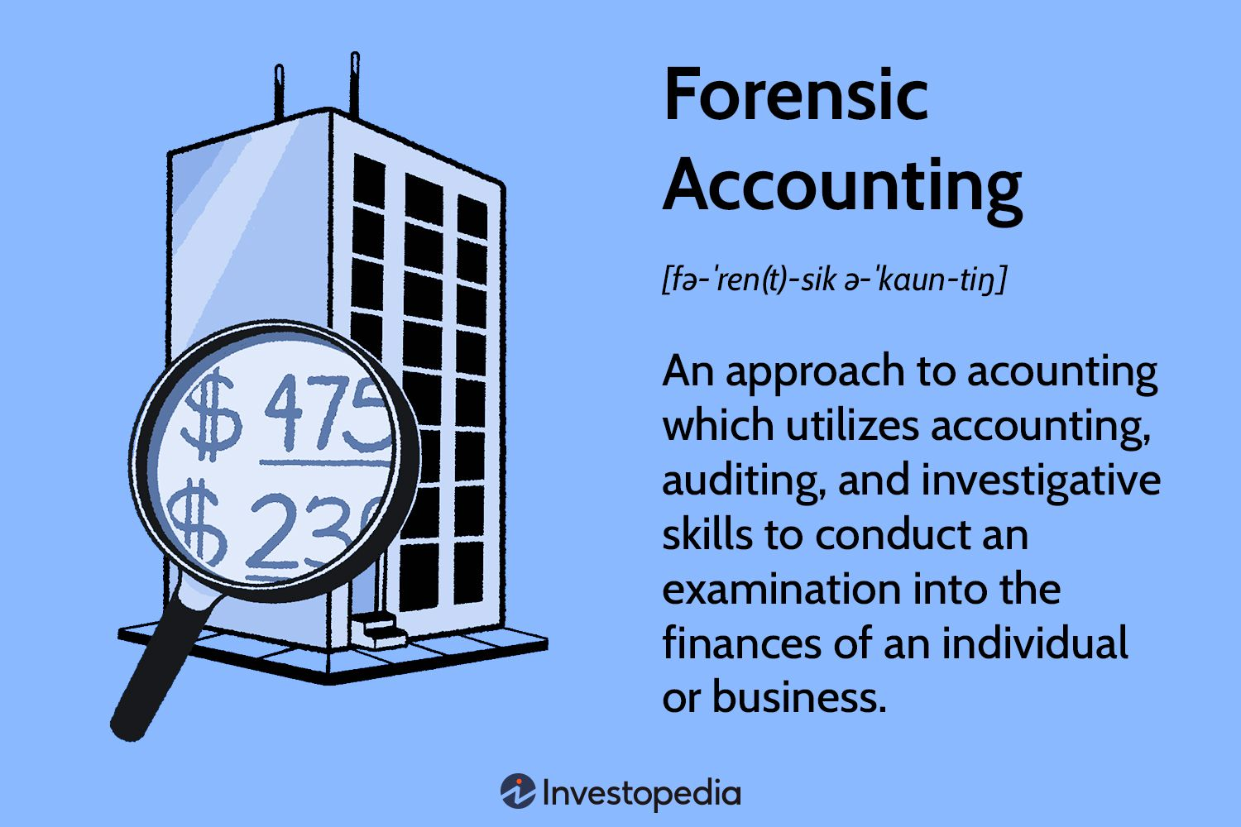

**As forensic accountants you may be working in areas such as:**

* Investigations, both criminal and civil
* Preparation and review of evidence
* Preparation of expert reports
* Affidavits and proof of evidence
* Giving oral evidence in court
* Expert determination, arbitration, mediation or alternative
* Dispute resolution

Insolvency support investigation and fraud prevention and awareness strategies

Qualified forensic accountants can provide attorneys with a variety of approaches to successfully resolve claims and disputes. From early-stage advisor to expert witness, forensic accountants give knowledgeable advice throughout the commercial or regulatory litigation process in an effort to ascertain and develop key financial data.

They can provide expert witness testimony supported by effective analysis, trial support by analysing materials and developing approaches to support the direct and/or cross examination process and comprehensive support for settlement scenarios.

So, what does it take to become a forensic accountant? Apart from a need for the same basic accounting skills that it takes to become a good auditor, to be a forensic accountant you need to have the ability to:

* Pay attention to the smallest detail
* Analyse data thoroughly
* Think creatively
* Possess common business sense
* Be proficient with a computer and; have excellent communication skills
* A "sixth sense" that can be used to reconstruct details of past accounting transactions is also beneficial
* A photographic memory helps when trying to visualise and reconstruct these past events.

A forensic accountant also needs the ability to maintain his composure when detailing these events on the witness stand and should be insensitive to personal attacks on his professional credibility.

One thing forensic accountants learn when conducting fraud investigations is that you can never assume, what appears to be one thing on the first glance often turns out to be quite different when examined closely.

An increasingly complex business environment and the growing tendency for people to take legal action has led to the demand for accountants who understand the legal process, and who can conduct investigations, financial analysis and other accounting or audit procedures at a level acceptable to the courts.

Forensic accountants gather information to form an opinion, which is generally expressed in a report or given as expert evidence in court. Due to the diversity of commercial matters which are brought before the courts, a Forensic Accountant's work is often far more challenging and interesting than the traditional compliance or statutory reporting work undertaken by many accountants in professional practice.

**The key areas of work for Forensic Accountants are:**

* Quantification of Damages and Loss of Profits
* Assessing the effect on profitability, cashflow, income or value, that a party claims to have incurred, or may incur, because of either a breach in a contract, personal injury, product liability, breaches of the Trade Practices Act or Fair Trading, etc.

The Forensic Accountant may also need to consider the impact of other circumstances on the claimed loss, and the degree to which the loss was mitigated or could have been mitigated in order to determine the actual loss incurred.

**Valuations**

Determining the value of shares, businesses, partnerships, intangibles, etc in dispute, lost or destroyed. The Forensic Accountant must review information as both a financial analyst and as an investigating accountant, making appropriate adjustments, where necessary, and applying a generally accepted, or arguable, methodology to determine the value.

**Professional Negligence**

Reviewing transactions and the actions, or inaction, of various professionals to determine whether the parties were negligent and, if so, to what extent.  
When a review involves an accounting professional, a keen knowledge of the applicable accounting standards and the prevailing law is required. Therefore, the Forensic Accountant must have the ability to identify the impact and timing of changes in law and procedures.

Fraud - investigating frauds and establishing procedures to prevent or detect fraud. Forensic Accountants are frequently called upon to investigate frauds, identify the appropriate documentary evidence, quantify the loss and to assist in the prosecution of those involved.

Family Law Matters - assessing the existence, value and ownership of the financial resources available to parties in matrimonial dispute. This type of work requires excellent communication skills when dealing with related party small family businesses where the personal emotions of the parties involved as frequently the financial information being considered frequently contains a mixture of business and personal transactions with tax driven results.

Forensic Accountants need to have an interest in and the aptitude to develop accounting, auditing, financial and investigative skills to recognise, document and analyse information frequently from hostile or opposing parties-that is required to form and support an opinion.

The Forensic Accountant must have the confidence and ability to respond immediately to questions raised in court. Further, and potentially even more important than knowing the answers, the Forensic Accountant must be able to communicate often extremely technical and complex financial information in a manner that will understood by the court