**Recruitment**

1. **Vocabulary**

Insert the following words in the gaps in the text below :

applicant, application, application form, apply, candidate, curriculum vitae or CV (GB) or resume (US) , employment agencies, interview, job description, job vacancies, references, short-listed

Many people looking for work read the ………………….advertised by companies and ……………………in newspapers or on the Internet. To reply to an advertisement is to……………………for job. (You become a ……………………..or an ………………….). You write an …………………….., or fill in the company’s…………………, and send it, along with your ………………….. and a covering letter.

You often have to give the names of two people who are prepared to write …………………for you. If your qualifications and abilities match the ………………., you might be ………………….,i.e selected to attend an …………………… .

1. **Discussion**

When employees ‘give notice’ i.e inform their employer that they will be leaving the company ( as soon as their contract allows), in what order should the company carry out the following steps?

1. Either hire a job agency (or for a senior post, a firm of headhunters), or advertise the vacancy
2. Establish whether there is an internal candidate who could be promoted (or moved sideways) to the job
3. Examine the job description for the post, to see whether it needs to be changed ( or indeed, whether the post needs to be filled)
4. Follow up the references of candidates who seem interesting
5. Invite the short-listed candidates for an interview
6. Make a final selection
7. Receive applications, curricula vitae and covering letters, and make a preliminary selection (a short-list)
8. Try to discover why the person has resigned
9. Write to all the other candidates to inform them that they have been unsuccessful

Complete the following chart with the letters A-I from the previous page











**Yes** **No**

**and**

**3) Case Study: Job Applications**

One day, you will apply for your first job as a business graduate. Unfortunately, many of your classmates, as well as lots of people you do not know, will probably also apply for the same job. Your experience and qualifications will probably be quite similar to those of most of the other candidates. You will submit a copy of your curriculum vitae or resume. But how do you get on the preliminary short-list? What kind of things do you think impress companies hiring business graduates?

Which of the following extracts from different CVs or application letters do you think would help the candidate to get an interview, and why?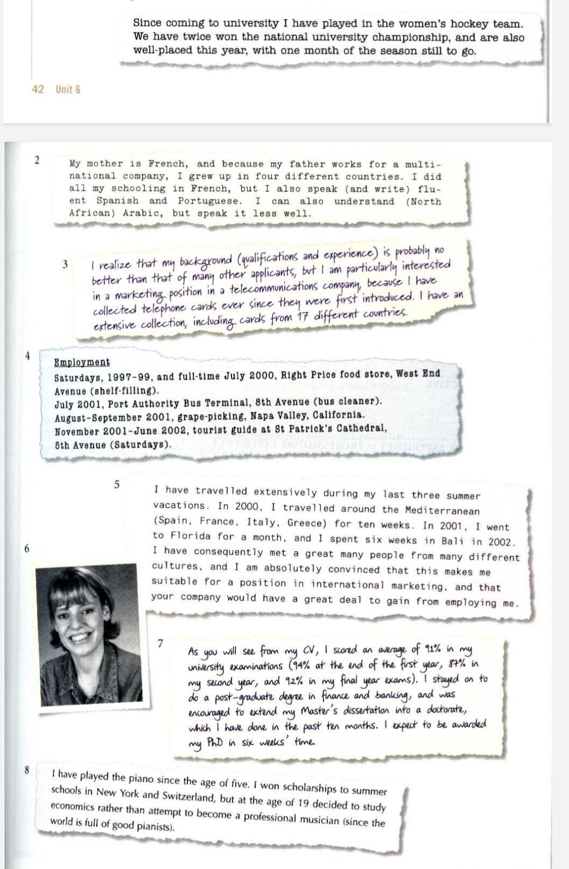

4) Curriculum Vitae or Resume:

This is a model of curriculum vitae or resume

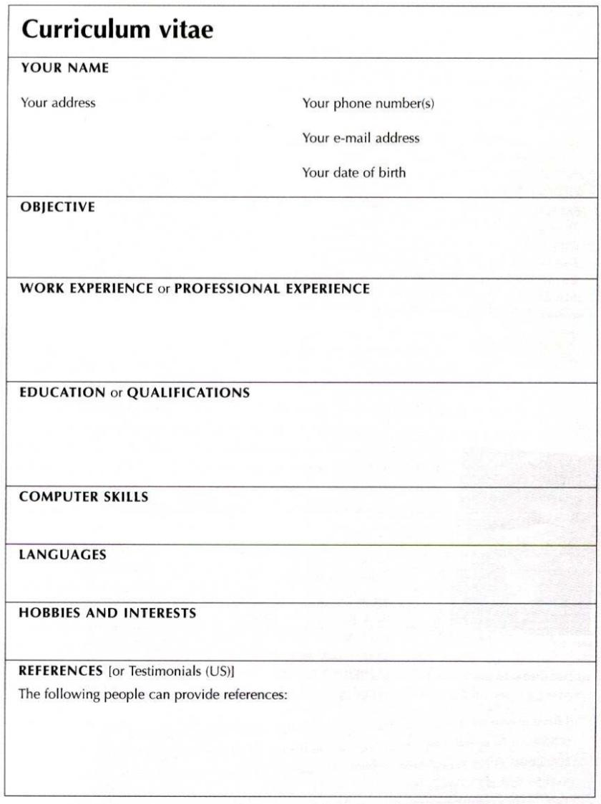

**5) Writing:**

According to the given model , write your personal curriculum vitae or resume