***Second course :what is digital marketing***

***Introduction :***

Businesses often use modern technology to advertise their business using techniques such as e-marketing and digital marketing. Knowing the difference between these marketing strategies can help an individual increase the chances of success of his business.

***What is electronic marketing?***

E- marketing refers to electronic marketing techniques that aim to interact with customers in order to better recognize the brand and achieve higher profits.

This technique uses platforms such as social media or blogs that communicate with their target audience rather than static, non-targeted ones, such as a billboard next to a highway.

Instead, marketers want to optimize their audiences using online analysis and interacting with them through social media, emails, and blogs. Since digital marketing uses technology to advertise, it is considered a subset of digital marketing that focuses on the Internet rather than all digital platforms.

***What is digital marketing?***

Digital marketing includes all types of electronic marketing techniques, including e-marketing. Digital marketing techniques focus on spreading brand recognition through multiple online platforms without expecting customer interaction in return. Digital marketing can take place online, for example through social media or search engines, or offline through electronic advertising on billboards or commercials on radio stations.

***Online Marketing vs. Digital Marketing: important Differences***

there are many similarities between digital and online marketing . However, the two techniques differ in important aspects. Here are some important differences between e-marketing and digital marketing:

1***Customer engagement versus brand recognition*** The goal of e-marketing is to build a relationship with customers through online engagement. Many e-commerce companies use e-marketing because it only exists online.

firms gain likes ,social media shares, and a loyal customer base through customer interaction.

2-The goal of digital marketing in general is to increase brand awareness. This means that digital marketing efforts rarely focus on customer interaction with their ads because their goal is to spread information about their products and services to many people as possible.

***Specific audience versus broad audience***

Digital marketing campaigns typically target specific audiences using ads that match and related with their interests. Ad targeting allows marketers to limit the number of people that reach through online platforms in order to create more specific and engaging content, which leads to more sales and customer satisfaction.

With digital marketing, the target audience is often broader in terms of interest. Local digital marketing ads in malls or on billboards target people in a specific geographic area and expect some of them to be interested in the products or services offered.

This tactic is very useful for essential or common services such as mechanics, grocery stores, and banks.

***Examples of electronic marketing :***

Ads on social media platforms often target potential customers based on their browsing history and interests. These ads can act the same work of social media posts and allow users to share them, leave comments, or follow a company page for more content.

**المثال الثاني**

Email campaigns:

Customers typically sign up for email campaigns that interest them, making this marketing technique useful for engaging with loyal customers. Businesses can send product updates and offers to existing customers, as well as promo codes to new customers.

Blogs: Blogs allow customers to learn more about the brand and interact with the company or other customers in the comments section. A company can also share its blogs on social media to start conversations with customers on different topics.

***examples of digital marketing :***

**Electronic billboards:** These billboards display digital ads that are visible at night and are easy to change.

Electronic billboards often promote local businesses in order to increase customer loyalty and familiarity

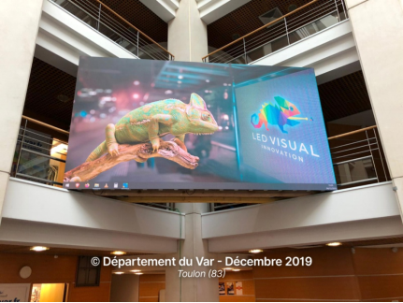 



***TV Ads:*** TV ads are another digital marketing tactic that can be local or wildespread.

These ads can be related with tv channels, for example : an advertisement for a new game on a children's cartoon channel :Ariel in Disney Junior



**Push Notifications:** Push notifications on smartphone apps are a way for digital marketers to constantly remind people about their offers. Although this method rarely generates new customers, it allows the company to stay in sync with existing customers example Shopping cart

C:\Users\DELL\AppData\Local\Temp\ksohtml13240\wps6.png

**In-App Ads:** In-app ads are another form of digital marketing that can increase a brand's customer base.A company displays its ads on apps that offer goods and services similar to those offered by the company.

Example : books or guides ads offered in an application which teach english .

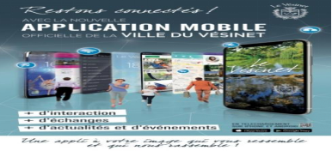

***Search Engine Ads***: Marketers can use search engine ads to target potential customers searching for a specific product.