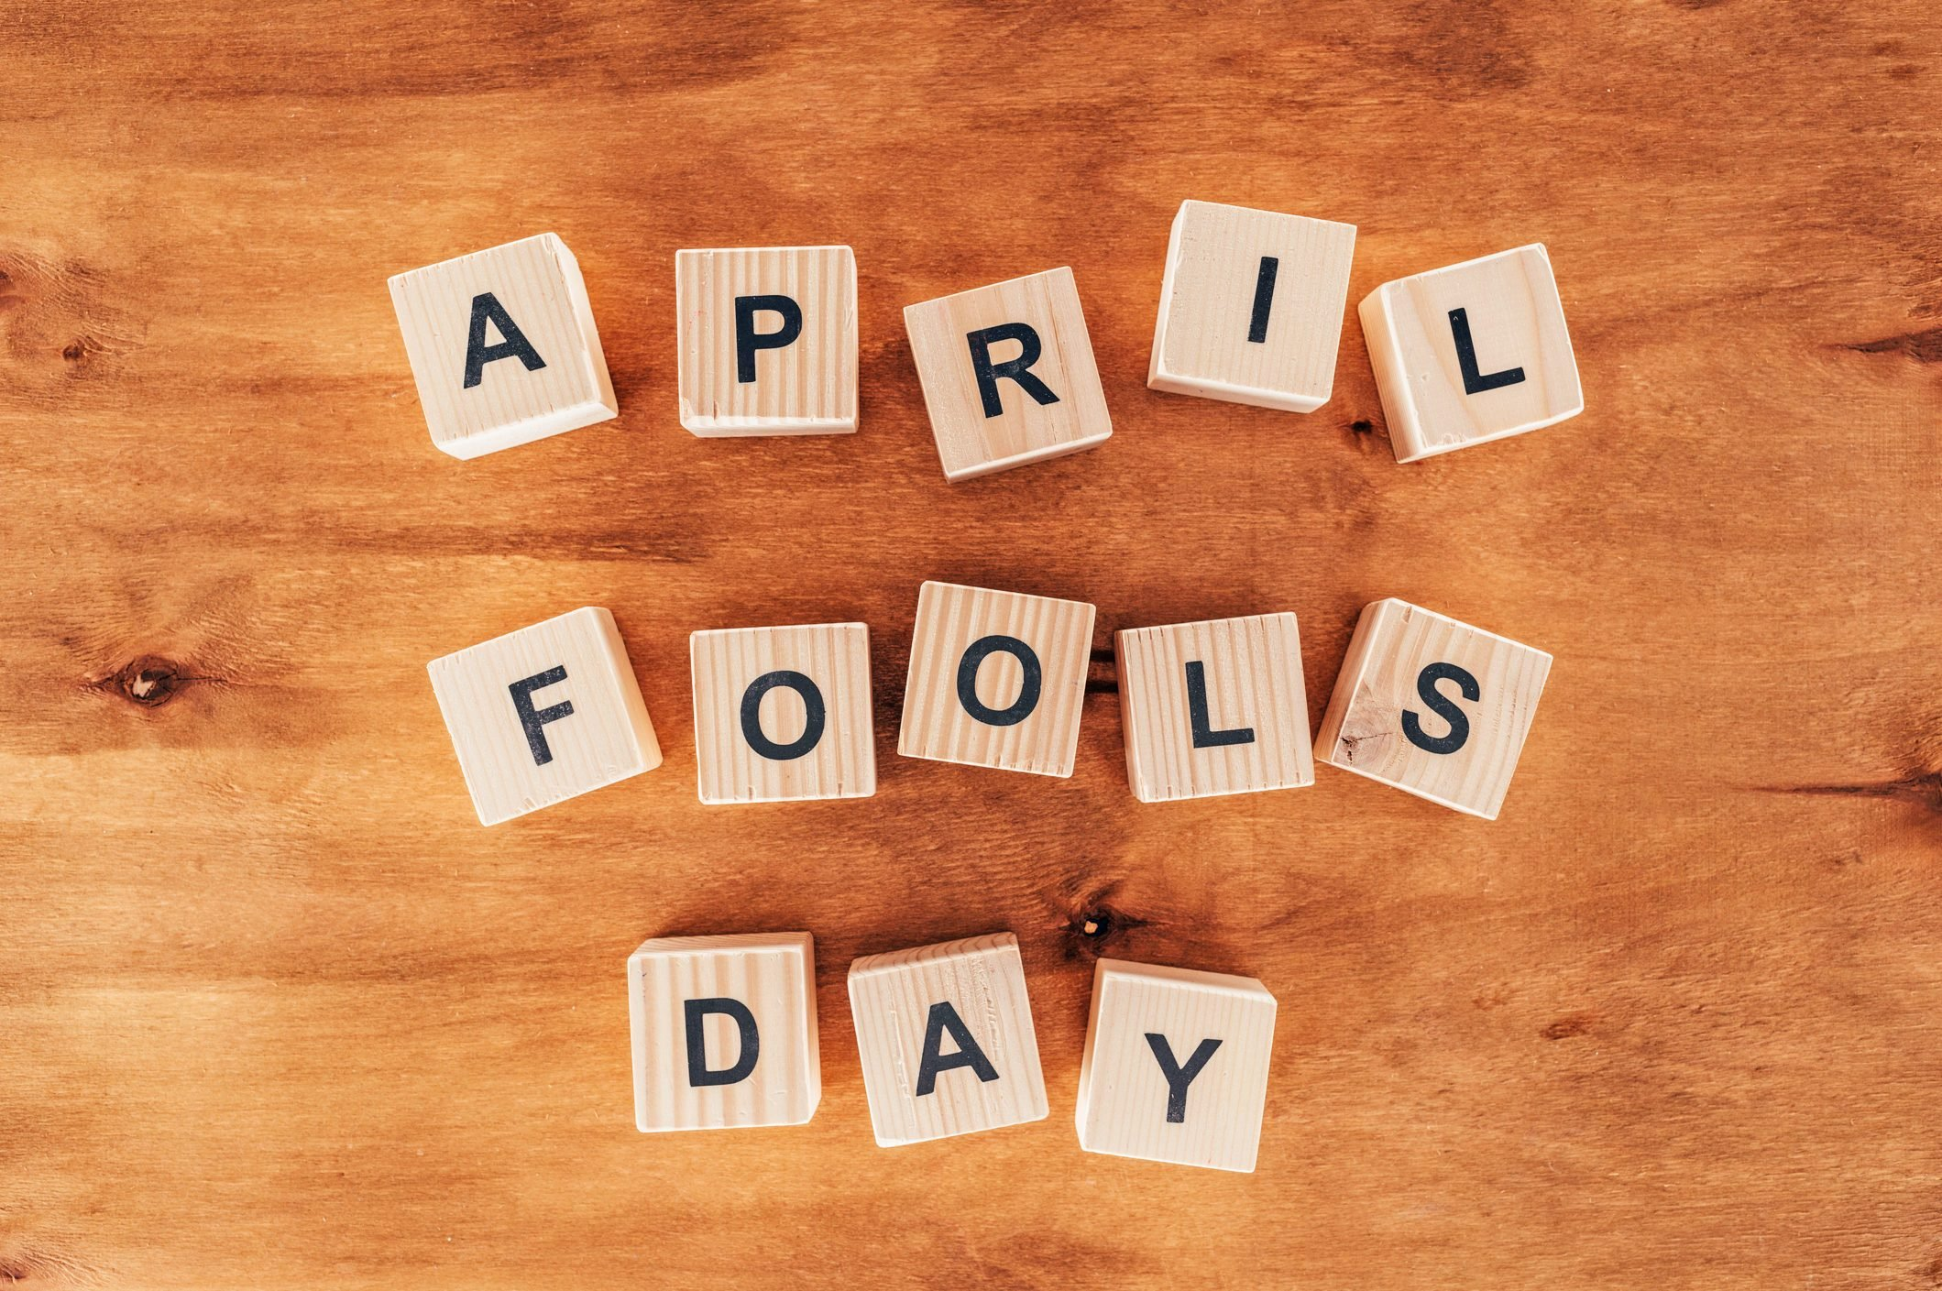

* + What do you know about April Fool’s Day?
  + Do you have a similar day in your country?
  + Do you like practical jokes?
  + Have you played a trick on anybody recently?
  + Who-s the joker in your class/ family

April Fool’s Day is a special day for jokes and tricks in many countries. Read this article to find out all about it.

Match the definitions (a–h) with the vocabulary (1–8).

**Vocabulary Definition**

1. …… a practical joke

2.…… to play a trick on someone

3. …… to fall for something

4. …… hilarious

5. …… an errand

6. …… a hoax

7. …… to fool someone

8. …… light-hearted

a. a trick to make people believe something that is not true

b. to be tricked into believing something that is not true

c. amusing; not serious

d. a trick that surprises someone and makes them look silly

e. a short trip you take in order to do something

f. to do something to somebody which makes people laugh

g. very funny

h. to trick someone

***April Fool’s Day***

April Fool’s Day is celebrated on 1 April in many countries around the world. On this day, people traditionally play practical jokes on each other and have fun trying to make other people believe things that are not true.

April Fool’s traditions:

In the UK, jokes and tricks can be played up until noon on 1 April. After midday it’s considered bad luck to play a trick. Anyone who forgets this and tries a joke in the afternoon becomes an ‘April Fool’ themselves.

So, what kind of jokes do people play? Well, a simple example would be telling your friend that their shoelaces are undone. Then, when they bend down to do them up, you shout, ‘April Fool!’, and they realise their shoelaces are fine. Maybe it’s not your kind of humour, but watch out, there’s always someone who will find it hilarious! In Ireland, a popular prank is to send someone on a ‘fool’s errand’. The victim is sent to deliver a letter, supposedly asking for help.

When the person receives the letter, they open it, read it and tell the poor messenger that they will have to take the letter to another person. This continues and the victim ends uptaking the message to several different people until someone feels sorry for them and shows them what the letter says: ‘Send the fool to someone else.’

In France, Belgium, the Netherlands, Italy and French-speaking areas of Canada and

Switzerland, the 1 April tradition is known as the ‘April Fish’. A common joke is to try to stick a paper fish onto a victim’s back without being noticed.

April Fool’s Day in the media Some newspapers, TV channels and well-known companies publish false news stories to fool people on 1 April. One of the earliest examples of this was in 1957, when a programme on the BBC, the UK’s national TV channel, broadcast a report on how spaghetti grew on trees. The film showed a family in Switzerland collecting spaghetti from trees and many people were fooled into believing it, as in the 1950s British people didn’t eat much pasta and many didn’t know how it was made! Most British people wouldn’t fall for the spaghetti trick today, but in 2008 the BBC managed to fool their audience again with their Miracles of Evolution trailer, which appeared to show some special penguins that had regained the ability to fly. Two major UK newspapers, The Daily Telegraph and the Daily Mirror, published the ‘important story’ on their front pages.

***Tasks***

**Task 1**

Are the sentences true or false?

Answer

1. In the UK, you can play an April Fool’s Day trick all day on 1 April.

2. In Ireland, the ‘fool’s errand’ joke usually involves only two people.

3. Very few people believed the 1957 April Fool’s story about spaghetti

growing on trees.

4. In 1998, a lot of people in the United States wanted to try the left-handed hamburger.

5. Some people say that April Fool’s Day can have positive health effects.

**Task 2**

Read the sentences and then write the correct form of the word in brackets in the gaps.

1. April Fool’s Day is a ……………………………… where people play tricks on each other. (celebrate)

2. The victim of the ‘fool’s errand’ joke is the ……………………………… . (message)

3. In French-speaking areas of Canada, 1 April is ……………………………… known as the ‘April Fish’. (tradition)

4. Thousands of customers went to Burger King after seeing an ……………………………… for a new burger. (advertise)

5. Burger King said its new hamburger was more ……………………………… for left-handed people. (comfort)

6. Fun and ……………………………… on April Fool’s Day can reduce stress levels. (laugh)

7. Many people find April Fool’s Day very ……………………………… . (enjoy)

8. After receiving thousands of prank calls, a ……………………………… for Dublin Zoo said staff had

‘lost their sense of humour’. (speak)

**Discussion**

Have you ever been tricked or played a trick on anybody?

Top ten tricks

In 1998 Burger King published an advert in the magazine USA Today offering new ‘Left-handed Whoppas’ for the 32 million left-handed Americans! Thousands of customers ordered the new burger in the restaurants!

A zoo in Japan said that they had a giant penguin that was 165cm tall and weighed 80 kilograms! In fact it was a man dressed up in a penguin suit.

In the night of March 31st 1989 hundreds of Londoners phoned the police to report an alien space craft they had seen in the sky. In fact it was a hoax and it was a hot air balloon that looked like a space craft.

Last year in the UK a children’s news programme said that scientists had invented a ‘Brain Band’. It was a coloured head band that you put on your head and it helped to make you more intelligent! On an on-line poll, 47% of the children who heard the news wanted to buy a ‘brain band’!

In 1949 a radio presenter in New Zealand told listeners that there were millions of wasps coming to invade. He told viewers to wear their socks over their trousers and to put honey on their doors. Millions of listeners believed him

In 1957 a very serious documentary programme on the BBC reported on the spaghetti trees in Switzerland. They said it was an excellent place to grow spaghetti! Hundreds of viewers phoned the BBC to ask where they could buy spaghetti trees.

In 1999 a music website claimed that Britney Spears had lied about her age. They said she was 28, not 17. Hundreds of people phoned her music label to ask how old Britney really was.

In Sweden in 1962 they have one television channel and all TV was in black and white. A scientist told viewers that they would see the TV in colour is they put a nylon stocking over the screen.

In 1976 a very famous British astronomer told radio listeners that at 9.47am the earth was going to experience a feeling of less gravity. He said that Jupiter and Pluto would cross and if listeners jumped in

the air at exactly 9.47am they would feel the sensation of having no gravity! Hundreds of listeners phoned the radio to say they had jumped and floated in the air!

A British newspaper printed an article saying that the European Union had decided to ban April Fool’s

Day! It was only a hoax.