Outright Futures Trading Strategies

Investors can speculate on the direction of a futures contract by going long (buy to open) or short (sell to open) a futures contract. Moreover, investors noticing price convergences or divergences between different contract months of the same future, or between two separate futures contracts, can speculate by establishing an outright futures calendar spread trade or pairs trade, respectively. Futures are not subject to Pattern Day Trading rules, unlike trading stocks or options. Investors seeking to speculate by day trading futures actively are not limited by how many day trades they perform within a trading session.

Buying/Long Individual Outright Futures

Investors speculating that the price of a futures contract will go up can establish a long position by buying to open the contract. An investor can profit from a long futures contract as the price rises. Losses occur when the futures contract price falls below the contract's purchase price or cost basis.

Selling/Short Outright Futures

Investors speculating that the price of a futures contract will go down can establish a short position by selling to open the contract. An investor can profit from a short futures contract as the price falls. Unlike long positions, losses occur from a short futures contract position when the price rises above the sale price.

Futures Trading Examples

Suppose you are bullish on gold. You take a long position on the precious metal at $1,700 and one contract (100 troy ounces). You close the position before it expires, at which point the price of gold is at $1,750. You would pay $1,700 instead of $1,750, $50 less than the new market price. You would benefit and the seller would lose out. But there is more to calculating a futures contract profit or loss (P/L). First, you would divide the profit per contract (or the difference between the futures price and the price at expiration/execution of trade)—$50 in this case, by the tick size (0.10 for gold futures). That gives you the total tick movement (500 ticks). Then you would multiply this with the tick value ($10 for gold futures), which gives you your total P/L. In this case, your profit is $5,000.

For a contract size bigger than 1, you would multiply this figure with the number of contracts to determine your P/L. Now imagine that you let the futures contract expire, at which point the price of gold is at $1,600. You would pay $1,700 instead of $1,600. That means you would have missed an opportunity to pay $100 less than the new market price. You would calculate the P/L as per the previous example. In this case, it would be $10,000. As per this example, you would lose out and the seller would benefit.

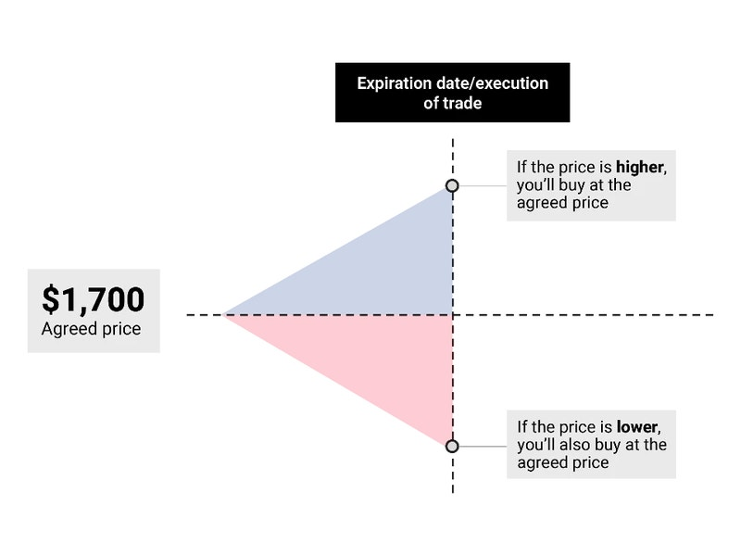

Outright Futures Calendar Spreads and Pairs Trades

Investors who notice price deviations between different contract months of a specific futures contract or notice that prices between two separate futures contracts are inverse can speculate by placing an outright futures calendar spread trade or pairs trade.

An outright futures calendar spread, or intramarket spread, describes a strategy where an investor buys or sells the active month futures contract and performs the opposite order action on the same future in a back-month contract. It is important to note that investors can speculate between any two contract months of a specific futures contract. It is worth noting that available contract months vary for each outright futures contract.

Similar to intramarket futures spreads, a futures pairs trade describes a strategy where an investor buys or sells a futures contract and performs the opposite order action to a different contract. Investors can speculate between the inverse price action of two futures contracts by placing a pairs trade. Whether an investor speculates by establishing an outright futures spread trade or a pairs trade, both have the same goal of price convergence or divergence.

Before we discuss an example, it is essential to understand what convergence and divergence mean in a futures calendar spread or pairs trade. Convergence assumes the two products or contracts are at price extremes far away from each other. A convergence would profit when the prices of the two products moved towards each other over time.



For example, if we are long the front-month /MESH4 futures contract at 4,000 and short the back-month /MESM4 futures contract at 4,050, we would see profitability if the price of the front-month contract rose, and the back-month contract fell. Of course, when the inverse occurs in the example above, we would see losses on both contracts.

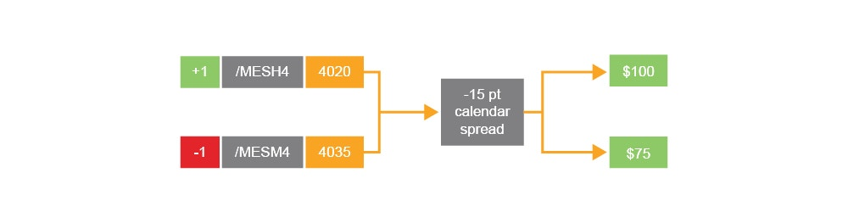

The example above shows the spread narrowing from -50 points to -15 points due to the long front month /MES contract increasing 20 points for a $100 gain (20 pts x $5) and the short back-month /MES contract dropping by 15 points for a $75 gain (15 pts x $5). This equates to a $175 total profit between the two contracts ($100 + $75).

Conversely, traders can speculate on a divergence. Traders speculating on a divergence assume the price of each futures contract in an outright futures calendar spread will move away from each other over time.



For example, let’s say we are short the front-month /MESH4 futures contract at 4,000 and long the back-month /MESM4 futures contract at 4,050. We would see profitability if the price of the front-month contract fell, and the back-month contract rose. Both contracts are moving away from each other or diverging. If the price of both contracts started moving toward each other, in this example, a loss would be incurred.

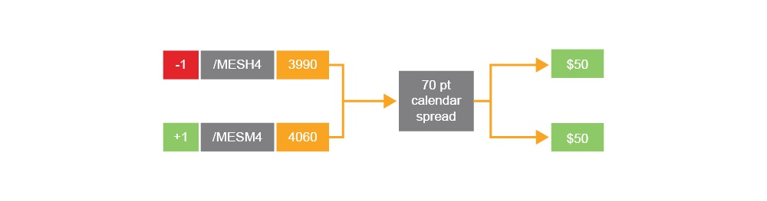

The example above shows the spread widening by 10 points due to the short front-month /MESH4 contract dropping by 10 points (from 4,000 to 3,990) for a $50 gain (10 pts x $5) and the long back-month /MESM4 contract rising by 10 points. This equates to a $100 profit between the two contracts.

Before establishing, it is essential to fully understand the risks of futures calendar spreads and pairs trades. The tastytrade desktop trading platform has the Pairs Trading mode for investors seeking to establish futures spread or futures pairs trade. Please visit the tastytrade Help Center to learn more about the [Pairs Trading mode](https://support.tastytrade.com/support/s/solutions/articles/43000571512).